**Virtual Pantry-art design**

website(ongoing):  
 <http://websys3.stern.nyu.edu/~gz580/websys/vitrualpantry/index.html>

Introduction:

We often find ourselves in situations where we are hungry, we want to eat healthily and we want to save money, but we only have 2-3 items in the refrigerator (oh and its cold outside!). What should we do? Should we take the hit and order in, should we just eat that packet of instant noodles or should we just curl up into a ball and sleep? We say, none of the above! Using this app you can find healthy and nutritious meals that require minimal ingredients (including those already in your refrigerator). So go ahead, try giving that healthy and frugal lifestyle a try.

Welcome to the Virtual Pantry.

**Deadline(Dec.12)**

Design part:

1. logo
2. logo picture without text (for heading)

e.g.





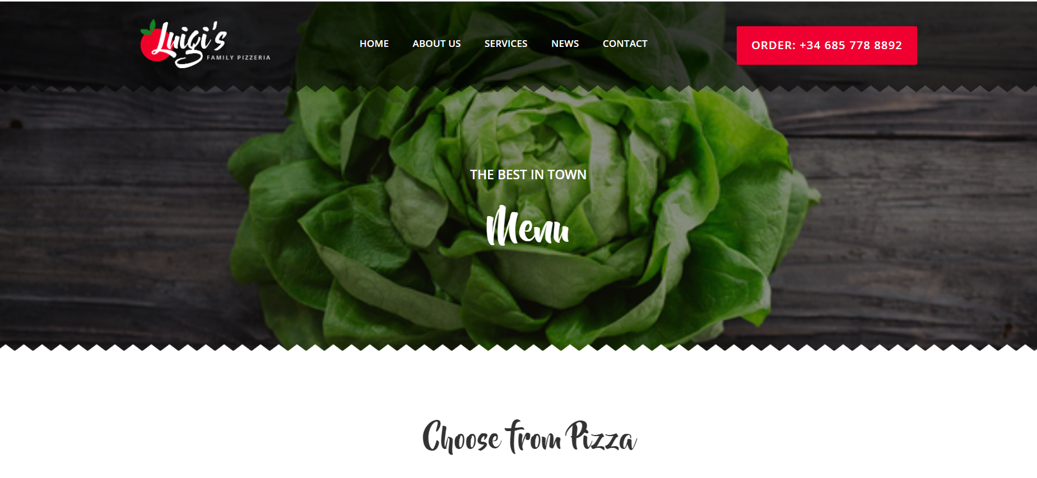



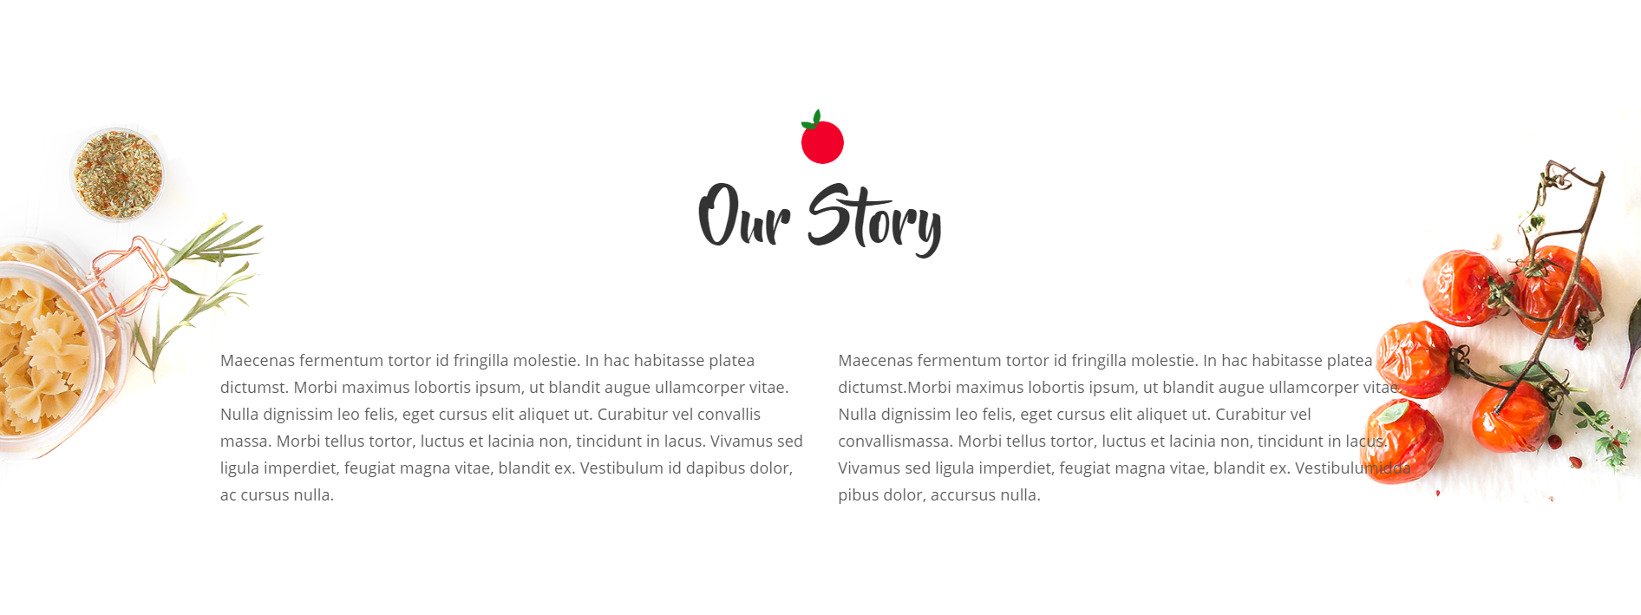

Requirements: